# VISVESVARAYA TECHNOLOGICAL UNIVERSITY

## BELAGAVI – 590018, Karnataka INTERNSHIP REPORT

#### ON

#### “Chatbot for Healthcare System Using AI”

***Submitted in partial fulfilment for the award of degree(21\*\*\*\****

## BACHELOR OF ENGINEERING IN

## COMPUTER SCIENCE and ENGINEERING

***Submitted by:***

**NAME: SAHIL MUBARAK**

**USN: 1SV21CS066**



Conducted at

**COMPSOFT TECHNOLOGIES**



**SHRIDEVI INSTITUTE OF ENGINEERING AND TECHNOLOGY**

**(Affiliated To Visvesvaraya Technological University)**

**Sira Road, Tumakuru – 572106, Karnataka. 2023-2024**

**SHRIDEVI INSTITUTE OF ENGINEERING AND TECHNOLOGY**

**(Affiliated To Visvesvaraya Technological University)**

**Sira Road, Tumakuru – 572106, Karnataka. 2023-2024**



**CERTIFICATE**

This is to certify that the Internship titled **“Chatbot for Healthcare System Using AI”** carried out by **Mr. Sahil Mubarak,** a bonafide student of Shridevi Institute of Engineering and Technology, in partial fulfillment for the award of **Bachelor of Engineering**, in **Computer Science and Engineering** under Visvesvaraya Technological University, Belagavi, during the year 2023-2024. It is certified that all corrections/suggestions indicated have been incorporated in the report.

The project report has been approved as it satisfies the academic requirements in respect of Internship prescribed for the course Internship / Professional Practice (21CSI85)

#### Signature of Guide Signature of HOD Signature of Principal

**External Viva:**

Name of the Examiner Signature with Date

1)

2)

# D E C L A R A T I O N

I, **Sahil Mubarak**, third year student of CSE, Shridevi Institute of Engineering and Technology, Tumakuru - 572106, declare that the Internship has been successfully completed, in **COMPSOFT TECHNOLOGIES**. This report is submitted in partial fulfillment of the requirements for award of Bachelor Degree in Computer Science and Engineering, during the academic year 2023-2024.

Date : 1/12/2023

Place: SIRA, TUMAKURU

USN : 1SV21CS066

NAME : SAHIL MUBARAK

**OFFER LETTER**

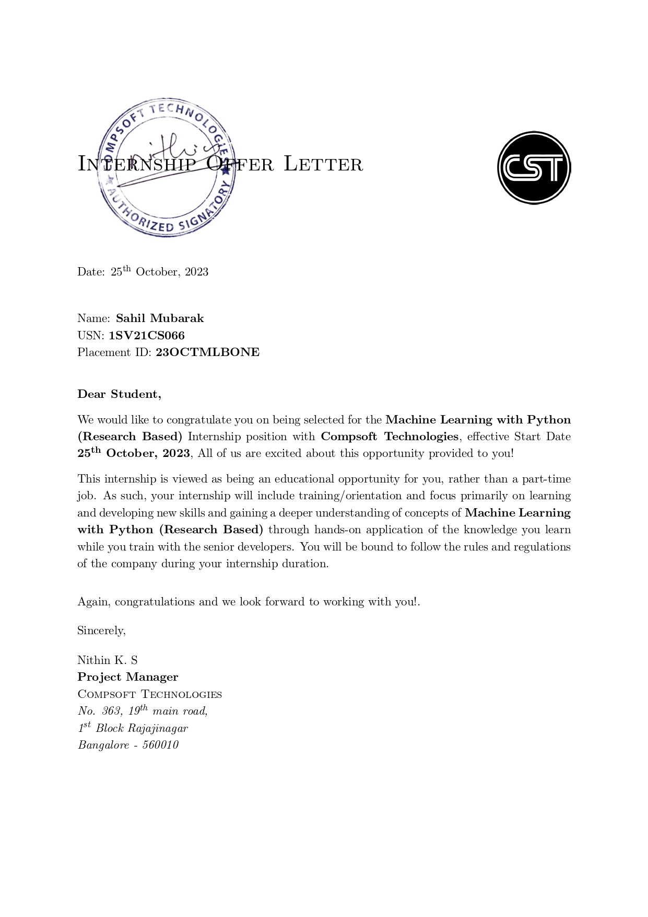

# A C K N O W L E D G E M E N T

This Internship is a result of accumulated guidance, direction and support of several important persons. We take this opportunity to express our gratitude to all who have helped us to complete the Internship.

We express our sincere thanks to our Principal, for providing us adequate facilities to undertake this Internship.

We would like to thank our Head of Dept – branch code, for providing us an opportunity to carry out Internship and for his valuable guidance and support.

We would like to thank our Lab assistant of Software Services for guiding us during the period of internship.

We express our deep and profound gratitude to my guide, for their keen interest and encouragement at every step in completing the Internship.

We would like to thank all the faculty members of our department for the support extended during the course of Internship.

We would like to thank the non-teaching members of our dept, for helping us during the Internship.

Last but not the least, we would like to thank our parents and friends without whose constant help, the completion of Internship would have not been possible.

**NAME: SAHIL MUBARAK**

**USN: 1SV21CS066**

# ABSTRACT

The Healthcare Chatbot project encompasses the development, deployment, and optimization of an AI-driven conversational agent tailored for medical inquiries.

The journey began with downloading project files and navigating installation processes, including addressing compatibility issues between Rasa versions. A critical error in loading the model led to two solutions: downgrading Rasa or retraining the model; the latter was pursued successfully.

The deployment process involves commands in GitBash for Rasa and Flask to host the bot locally. However, limitations surfaced during testing, such as repetitive responses for diverse health topics. A comprehensive analysis of project files highlighted the significance of intent and action files, leading to modifications in the training data.

Despite initial testing challenges, the bot's functionalities were enhanced by introducing new stories and addressing errors in actions. Further, the project delved into refining the user interface, adjusting HTML, CSS, and JS files for an appealing frontend. Notably, overcoming action-related errors in the chat process required additional file adjustments.

The quest for testing accuracy involved extensive research, culminating in the identification of Rasa commands to validate the chatbot's responses. To augment the bot's capabilities, modifications were made to support multiple responses and symptoms in the data files. The abstract encapsulates the project's evolution, challenges faced, and the iterative process of enhancing a healthcare chatbot for improved user interaction and accuracy.

# Table of Contents

|  |  |  |
| --- | --- | --- |
| **Sl no** | **Description** | **Page no** |
| 1 | Company Profile | 9 |
| 2 | About the Company | 11 |
| [3](https://1.bp.blogspot.com/-dODuK8N5h1Q/Wlnyb3V9HFI/AAAAAAAACL4/WxQtCJ1pM5wccDABg4wIrTBUB0vlikXQQCLcBGAs/s1600/poly1.jpg) | Introduction | 15 |
| [4](https://1.bp.blogspot.com/-dODuK8N5h1Q/Wlnyb3V9HFI/AAAAAAAACL4/WxQtCJ1pM5wccDABg4wIrTBUB0vlikXQQCLcBGAs/s1600/poly1.jpg) | System Analysis | 17 |
| [5](https://1.bp.blogspot.com/-dODuK8N5h1Q/Wlnyb3V9HFI/AAAAAAAACL4/WxQtCJ1pM5wccDABg4wIrTBUB0vlikXQQCLcBGAs/s1600/poly1.jpg) | Requirement Analysis | 19 |
| 6 | Design [Analysis](https://4.bp.blogspot.com/-IOOxgPaXMVc/Wlj3LWvcnjI/AAAAAAAACKE/UeTFYvAxDmUDel5UBjdifeWaApB3-dXVgCLcBGAs/s1600/img1.jpg) | 21 |
| 7 | [Implementation](https://4.bp.blogspot.com/-IOOxgPaXMVc/Wlj3LWvcnjI/AAAAAAAACKE/UeTFYvAxDmUDel5UBjdifeWaApB3-dXVgCLcBGAs/s1600/img1.jpg) | 23 |
| 8 | Snapshots | 25 |
| 9 | Conclusion | 29 |
| 10 | References | 31 |

[**CHAPTER**](https://1.bp.blogspot.com/-dODuK8N5h1Q/Wlnyb3V9HFI/AAAAAAAACL4/WxQtCJ1pM5wccDABg4wIrTBUB0vlikXQQCLcBGAs/s1600/poly1.jpg) **1** **COMPANY PROFILE**

# COMPANY PROFILE

## A Brief History of Compsoft Technologies

Compsoft Technologies, was incorporated with a goal ”To provide high quality and optimal Technological Solutions to business requirements of our clients”. Every business is a different and has a unique business model and so are the technological requirements. They understand this and hence the solutions provided to these requirements are different as well. They focus on clients requirements and provide them with tailor made technological solutions. They also understand that Reach of their Product to its targeted market or the automation of the existing process into e-client and simple process are the key features that our clients desire from Technological Solution they are looking for and these are the features that we focus on while designing the solutions for their clients.

Sarvamoola Software Services. is a Technology Organization providing solutions for all web design and development, MYSQL, PYTHON Programming, HTML, CSS, ASP.NET and LINQ. Meeting the ever increasing automation requirements, Sarvamoola Software Services. specialize in ERP, Connectivity, SEO Services, Conference Management, effective web promotion and tailor-made software products, designing solutions best suiting clients requirements.

Compsoft Technologies, strive to be the front runner in creativity and innovation in software development through their well-researched expertise and establish it as an out of the box software development company in Bangalore, India. As a software development company, they translate this software development expertise into value for their customers through their professional solutions.

They understand that the best desired output can be achieved only by understanding the clients demand better. Compsoft Technologies work with their clients and help them to defiine their exact solution requirement. Sometimes even they wonder that they have completely redefined their solution or new application requirement during the brainstorming session, and here they position themselves as an IT solutions consulting group comprising of high caliber consultants.

They believe that Technology when used properly can help any business to scale and achieve new heights of success. It helps Improve its efficiency, profitability, reliability; to put it in one sentence ” Technology helps you to Delight your Customers” and that is what we want to achieve.

# [CHAPTER](https://1.bp.blogspot.com/-dODuK8N5h1Q/Wlnyb3V9HFI/AAAAAAAACL4/WxQtCJ1pM5wccDABg4wIrTBUB0vlikXQQCLcBGAs/s1600/poly1.jpg) 2 ABOUT THE COMPANY

1. **ABOUT THE COMPANY**



Compsoft Technologies is a Technology Organization providing solutions for all web design and development, MYSQL, PYTHON Programming, HTML, CSS, ASP.NET and LINQ. Meeting the ever increasing automation requirements, Compsoft Technologies specialize in ERP, Connectivity, SEO Services, Conference Management, effective web promotion and tailor-made software products, designing solutions best suiting clients requirements. The organization where they have a right mix of professionals as a stakeholders to help us serve our clients with best of our capability and with at par industry standards. They have young, enthusiastic, passionate and creative Professionals to develop technological innovations in the field of Mobile technologies, Web applications as well as Business and Enterprise solution. Motto of our organization is to “Collaborate with our clients to provide them with best Technological solution hence creating Good Present and Better Future for our client which will bring a cascading a positive effect in their business shape as well”. Providing a Complete suite of technical solutions is not just our tag line, it is Our Vision for Our Clients and for Us, We strive hard to achieve it.

## Products of Compsoft Technologies.

**Android Apps**

It is the process by which new applications are created for devices running the Android operating system. Applications are usually developed in Java (and/or Kotlin; or other such option) programming language using the Android software development kit (SDK), but other development environments are also available, some such as Kotlin support the exact same Android APIs (and bytecode), while others such as Go have restricted API access.

The Android software development kit includes a comprehensive set of development tools. These include a debugger, libraries, a handset emulator based on QEMU, documentation, sample code, and zutorials. Currently supported development platforms include computers running Linux (any modern desktop Linux distribution), Mac OS X 10.5.8 or later, and Windows 7 or later. As of March 2015, the SDK is not available on Android itself, but softwaredevelopment is possible by using specialized Android applications.

**Web Application**

It is a client–server computer program in which the client (including the user interface and client- side logic) runs in a web browser. Common web applications include web mail, online

retail sales, online auctions, wikis, instant messaging services and many other functions. web applications use web documents written in a standard format such as HTML and JavaScript,which are supported by a variety of web browsers. Web applications can be considered as a specifific variant of client–server software where the client software is downloaded to the client machine when visiting the relevant web page, using standard procedures such as HTTP. The Client web software updates may happen each time the web page is visited. During the session, the web browser interprets and displays the pages, and acts as the universal client for any web application. The use of web application frameworks can often reduce the number of errors in a program, both by making the code simpler, and by allowing one team to concentrate on the framework while another focuses on a specifified use case. In applications which are exposed to constant hacking attempts on the Internet, security- related problems can be caused by errors in the program.

Frameworks can also promote the use of best practices such as GET after POST. There are some who view a web application as a two-tier architecture. This can be a “smart” client that performs all the work and queries a “dumb” server, or a “dumb” client that relies on a “smart” server. The client would handle the presentation tier, the server would have the database (storage tier), and the business logic (application tier) would be on one of them or on both. While this increases the scalability of the applications and separates the display and the database, it still doesn‟t allow for true specialization of layers, so most applications will outgrow this model. An emerging strategy for application software companies is to provide web access to software previously distributed as local applications. Depending on the type of application, it may require the development of an entirely different browser-based interface, or merely adapting an existing application to use different presentation technology. These programs allow the user to pay a monthly or yearly fee for use of a software application without having to install it on a local hard drive. A company which follows this strategy is known as an application service provider (ASP), and ASPs are currently receiving much attention in the software industry.

Security breaches on these kinds of applications are a major concern because it can involve both enterprise information and private customer data. Protecting these assets is an important part of any web application and there are some key operational areas that must be included in the development process. This includes processes for authentication, authorization, asset handling, input, and logging and auditing. Building security into the applications from the beginning can be more effective and less disruptive in the long run.

**Web design**

It is encompasses many different skills and disciplines in the production and maintenance of websites. The different areas of web design include web graphic design; interface design; authoring, including standardized code and proprietary software; user experience design; and

search engine optimization. The term web design is normally used to describe the design process relating to the front-end (client side) design of a website including writing mark up. Web design partially overlaps web engineering in the broader scope of web development. Web designers are expected to have an awareness of usability and if their role involves creating mark up then they are also expected to be up to date with web accessibility guidelines. Web design partially overlaps web engineering in the broader scope of web development.

## Departments and services offered

Compsoft Technologies plays an essential role as an institute, the level of education, development of student’s skills are based on their trainers. If you do not have a good mentor then you may lag in many things from others and that is why we at Compsoft Technologies gives you the facility of skilled employees so that you do not feel unsecured about the academics. Personality development and academic status are some of those things which lie on mentor’s hands. If you are trained well then you can do well in your future and knowing its importance of Compsoft Technologies always tries to give you the best.

They have a great team of skilled mentors who are always ready to direct their trainees in the best possible way they can and to ensure the skills of mentors we held many skill development programs as well so that each and every mentor can develop their own skills with the demands of the companies so that they can prepare a complete packaged trainee.

## Services provided by Compsoft Technologies.

* Core Java and Advanced Java
* Web services and development
* Dot Net Framework
* Python
* Selenium Testing
* Conference / Event Management Service
* Academic Project Guidance
* On The Job Training
* Software Training

# [CHAPTER](https://1.bp.blogspot.com/-dODuK8N5h1Q/Wlnyb3V9HFI/AAAAAAAACL4/WxQtCJ1pM5wccDABg4wIrTBUB0vlikXQQCLcBGAs/s1600/poly1.jpg) 3 INTRODUCTION

1. **INTRODUCTION**

## Introduction to ML

## 

In the ever-evolving landscape of technology, Machine Learning (ML) stands as a beacon of innovation, reshaping the way computers comprehend and respond to the world. At its essence, ML harnesses the power of algorithms to enable systems to learn iteratively from data, offering an adaptive approach to problem-solving. The versatility of ML is underscored by its diverse methodologies, each tailored to distinct challenges.

Supervised learning forms the bedrock, teaching models to make predictions by learning from labeled datasets. On the other hand, unsupervised learning unveils latent patterns in unlabeled data, fostering a deeper understanding of complex relationships. Reinforcement learning, drawing inspiration from human behavioral learning, propels systems to optimize decisions through continual feedback. The advent of deep learning, with its multi-layered neural networks, has propelled ML to new heights, particularly in tasks like image recognition and natural language processing.

Beyond its technical prowess, the impact of ML resonates across industries, revolutionizing healthcare diagnostics, streamlining financial analysis, and enhancing user experiences in virtual assistants. The journey of Machine Learning is marked not just by automation but by a profound redefinition of what's possible, laying the groundwork for a future where intelligent systems seamlessly integrate into the fabric of our daily lives, ushering in a new era of technological possibilities.

## Problem Statement

Access to healthcare is crucial for a well-rounded life, yet the challenge of securing timely consultations with healthcare professionals persists. Obtaining a doctor's advice for every health concern is often cumbersome. The proposed solution addresses this predicament by leveraging Artificial Intelligence to develop a medical chatbot. This chatbot aims to diagnose diseases and furnish essential information about them, serving as a preliminary resource before seeking formal medical consultation. The envisioned outcome is a reduction in healthcare costs and enhanced accessibility to medical knowledge, fostering a more informed and empowered approach to individual well-being through the integration of medical chatbots.

# [CHAPTER](https://1.bp.blogspot.com/-dODuK8N5h1Q/Wlnyb3V9HFI/AAAAAAAACL4/WxQtCJ1pM5wccDABg4wIrTBUB0vlikXQQCLcBGAs/s1600/poly1.jpg) 4 SYSTEM ANALYSIS

**4. SYSTEM ANALYSIS**

## Existing System

**RASA Framework Usage:** Utilizes RASA for chatbot training and operation.

Framework version is outdated, posing potential compatibility challenges.

**Frontend Website:** Rudimentary design and functionality.

Lacks sophistication for an optimal user experience.

**Bot Responses:** Proficient in delivering responses.

Limited in the variety and depth of interactions.

## Proposed System

**Framework Upgrade:** Update RASA to the latest version for improved compatibility and access to new features.

**Frontend Refinement:** Enhance the design and functionality of the frontend website for a more user-friendly experience.

**Conversational Enrichment:** Expand training data to broaden the bot's conversational scope and provide more varied responses.

## Objective of the System

The primary objective of the system is to advance the capabilities of the healthcare chatbot, leveraging artificial intelligence through the RASA framework. The key goals include:

**Enhanced Compatibility:** Upgrade the RASA framework to the latest version for improved compatibility, ensuring seamless integration with modern technologies.

**Optimized User Interface:** Refine and optimize the frontend website to provide a more sophisticated and user-friendly interface, enhancing the overall user experience.

**Diversified Conversational Scope:** Expand the chatbot's training data to encompass a broader range of topics and interactions, enabling the system to deliver more varied and comprehensive responses.

By achieving these objectives, the system aims to overcome current limitations, offering an upgraded and more effective healthcare chatbot that caters to user needs with enhanced responsiveness and versatility.

# [CHAPTER](https://1.bp.blogspot.com/-dODuK8N5h1Q/Wlnyb3V9HFI/AAAAAAAACL4/WxQtCJ1pM5wccDABg4wIrTBUB0vlikXQQCLcBGAs/s1600/poly1.jpg) 5 REQUIREMENT ANALYSIS

**5. REQUIREMENT ANALYSIS**

## Hardware Requirement Specification

**1. Processor:** Dual-Core Processor, Adequate for running the chatbot locally without extensive concurrent processing needs.

**2. RAM:** 4GB RAM, Sufficient for basic model inference and handling moderate user interactions.

**3. Storage:** Storage Space, The 300MB project file can comfortably fit within the available storage.

**4. Graphics:** Integrated Graphics, Since the chatbot primarily operates in a text-based interface, a dedicated graphics card is not essential for local deployment.

These requirements indicate that the chatbot can operate on a modest system configuration for local development and testing. However, for larger-scale deployments or more resource-intensive tasks, considering additional resources like a more powerful processor and increased RAM may be beneficial

## Software Requirement Specification

**1. Operating System:** Compatible with the Windows operating system.

**2.Development Tools:**

Git Bash: Installed for version control and command-line operations.

Visual Studio Code (VSCode) or other Integrated Development Environment (IDE)

**3.Web Browser:**

Google Chrome or any other browser with developer options

**4.Programming Language:**

Python: Required for running the Rasa chatbot and Flask server.

**5.Libraries/Frameworks:**

Rasa: Open-source conversational AI framework for building chatbots.

Flask: Lightweight web framework for creating the web interface.

Requests: Python library for making HTTP requests, used in the Flask application.

# [CHAPTER](https://1.bp.blogspot.com/-dODuK8N5h1Q/Wlnyb3V9HFI/AAAAAAAACL4/WxQtCJ1pM5wccDABg4wIrTBUB0vlikXQQCLcBGAs/s1600/poly1.jpg) 6 DESIGN ANALYSIS

1. **DESIGN & ANALYSIS**

**1. Architecture:** The project adopts a client-server architecture, where the Rasa-based chatbot serves as the backend and a Flask-powered web application acts as the frontend. Communication between the frontend and backend is established through HTTP requests.

**2. Technological Stack:**

**Backend**:

Rasa: Utilized for natural language processing, intent recognition, and response generation.

Flask: Employed to create a lightweight web server handling communication between the user interface and the Rasa chatbot.

Python: The primary programming language for backend logic and server-side operations.

**Frontend**:

HTML, CSS, JavaScript (jQuery): Used to design and implement the user interface, facilitating user-bot interactions.

jQuery simplifies DOM manipulation and asynchronous communication with the Rasa backend.

**3.** **User Interface (UI):** The frontend consists of two main areas - an informative section to the left and a chat area to the right. A user input section is positioned at the bottom of the chat area, allowing users to interact seamlessly.

**4.Chatbot Functionality:**

Rasa is responsible for processing user input, generating appropriate responses, and enhancing the conversational experience.

The chatbot fetches responses from the Rasa backend through a Flask route ("/get") upon user input.

**5.Responsive Design:** The UI design incorporates responsiveness, ensuring an optimal viewing experience across various devices and screen sizes. The fixed positioning of the user input area at the bottom of the chat ensures it remains accessible during scrolling.

**6. Local Deployment:** Users can run the chatbot locally, requiring standard software such as Git Bash, VSCode, and browser developer options.

**Hardware Requirements:** The project runs smoothly on a system with 4GB RAM, an Intel dual-core chip, and no dedicated graphics card.

This design analysis highlights the project's technical stack, user interface considerations, chatbot functionality, and deployment aspects, setting the stage for potential improvements and future developments.

# [CHAPTE](https://1.bp.blogspot.com/-dODuK8N5h1Q/Wlnyb3V9HFI/AAAAAAAACL4/WxQtCJ1pM5wccDABg4wIrTBUB0vlikXQQCLcBGAs/s1600/poly1.jpg)R 7 IMPLEMENTATION

1. **IMPLEMENTATION**

Implementation is the stage where the theoretical design is turned into a working system. The most crucial stage in achieving a new successful system and in giving confidence on the new system for the users that it will work efficiently and effectively.

The system can be implemented only after thorough testing is done and if it is found to work according to the specification. It involves careful planning, investigation of the current system and it constraints on implementation, design of methods to achieve the change over and an evaluation of change over methods a part from planning.

Two major tasks of preparing the implementation are education and training of the users and testing of the system. The more complex the system being implemented, the more involved will be the system analysis and design effort required just for implementation.

The implementation phase comprises of several activities. The required hardware and software acquisition is carried out. The system may require some software to be developed. For this, programs are written and tested. The user then changes over to his new fully tested system and the old system is discontinued.

## TESTING

The testing phase is an important part of software development. It is the Information zed system will help in automate process of finding errors and missing operations and also a complete verification to determine whether the objectives are met and the user requirements are satisfied. Software testing is carried out in three steps:

1. The first includes unit testing, where in each module is tested to provide its correctness, validity and also determine any missing operations and to verify whether the objectives have been met. Errors are noted down and corrected immediately.
2. Unit testing is the important and major part of the project. So errors are rectified easily in particular module and program clarity is increased. In this project entire system is divided into several modules and is developed individually. So unit testing is conducted to individual modules.
3. The second step includes Integration testing. It need not be the case, the software whose modules when run individually and showing perfect results, will also show perfect results when run as a whole.

# [CHAPTE](https://1.bp.blogspot.com/-dODuK8N5h1Q/Wlnyb3V9HFI/AAAAAAAACL4/WxQtCJ1pM5wccDABg4wIrTBUB0vlikXQQCLcBGAs/s1600/poly1.jpg)R 8 SNAPSHOTS

* 1. **SNAPSHOTS**

**Starting RASAbot Server:**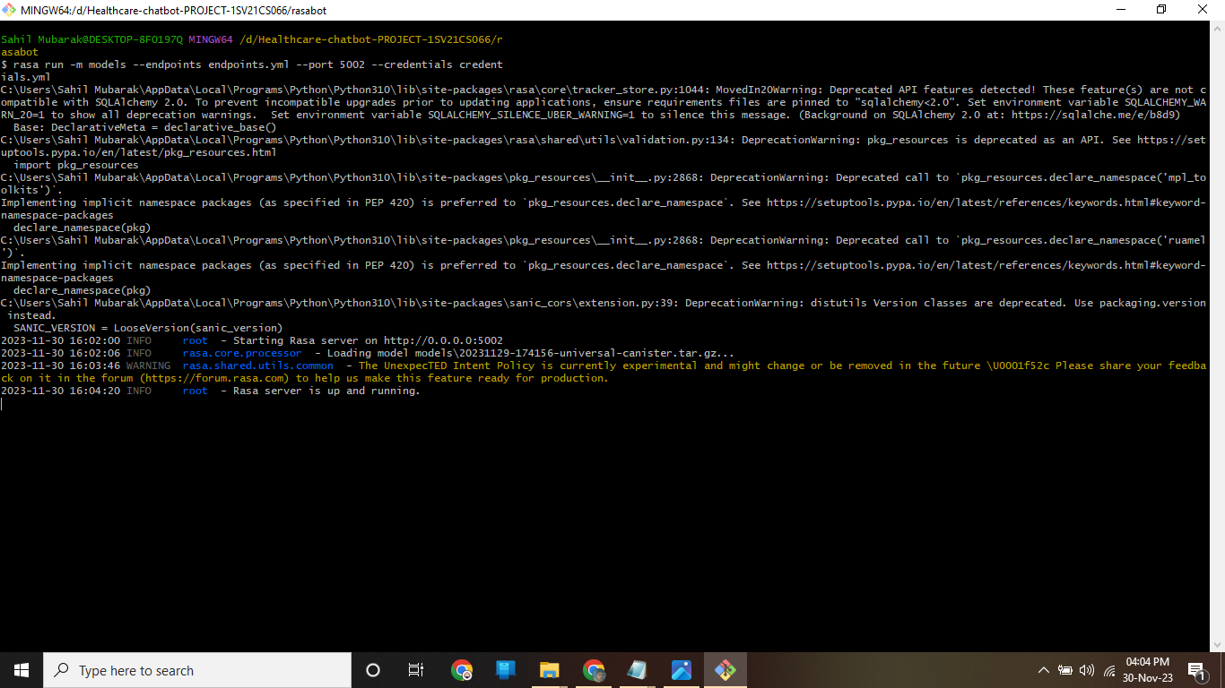

**Starting Flask App:**

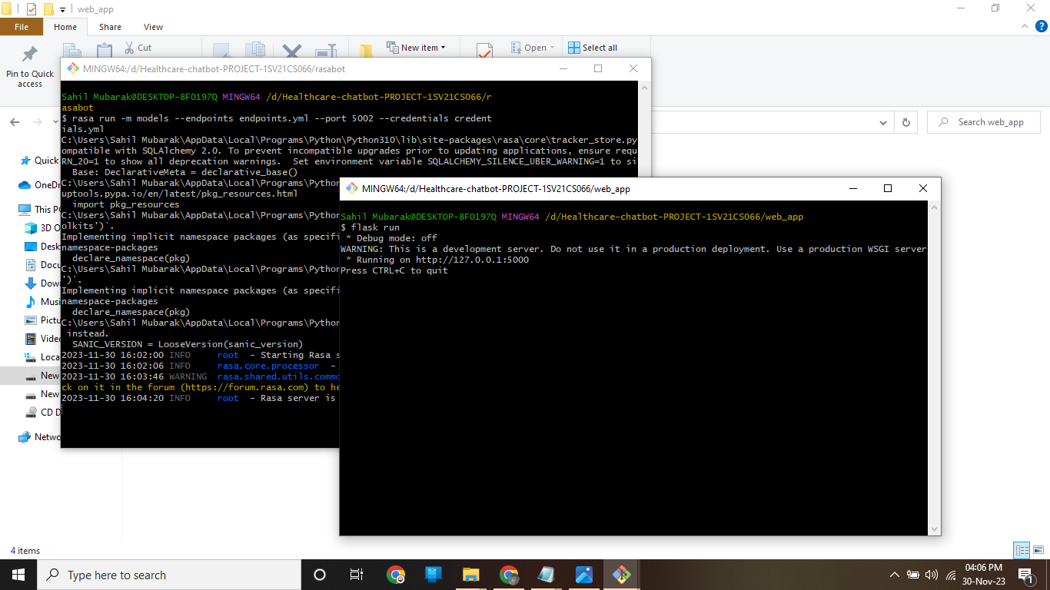

**Functioning ChatBot:**

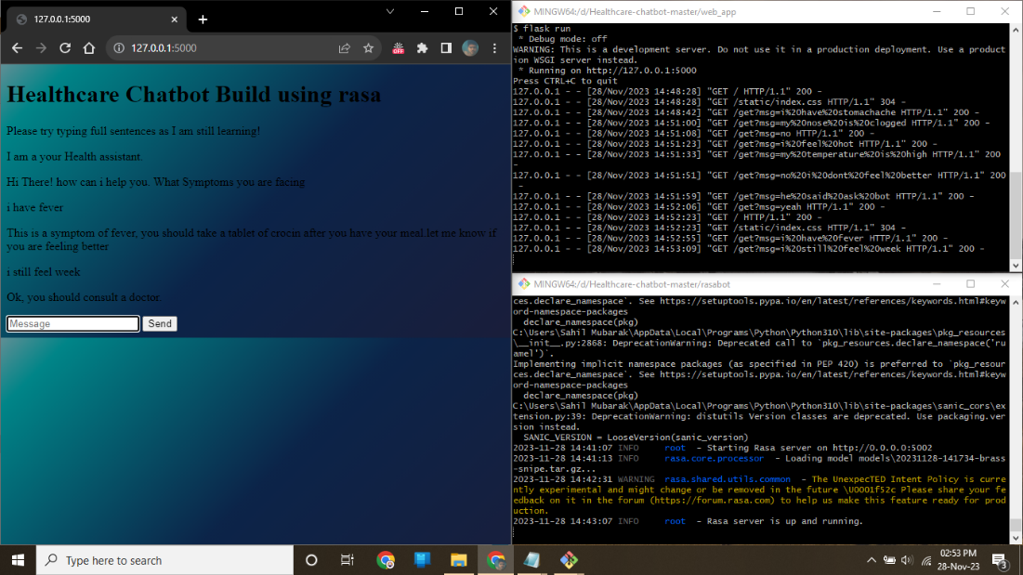

**Modifying the data to add more Responses:**

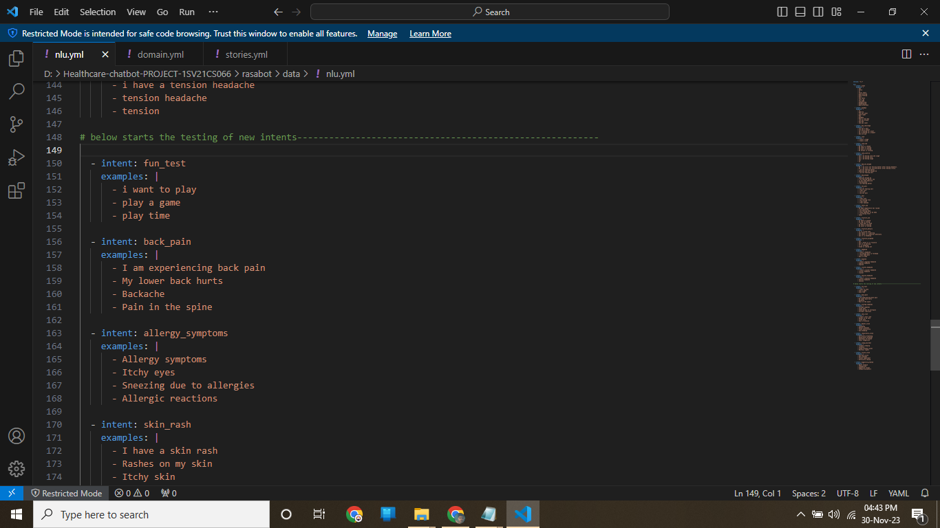

**Retraining the Bot with the Modified Data:**

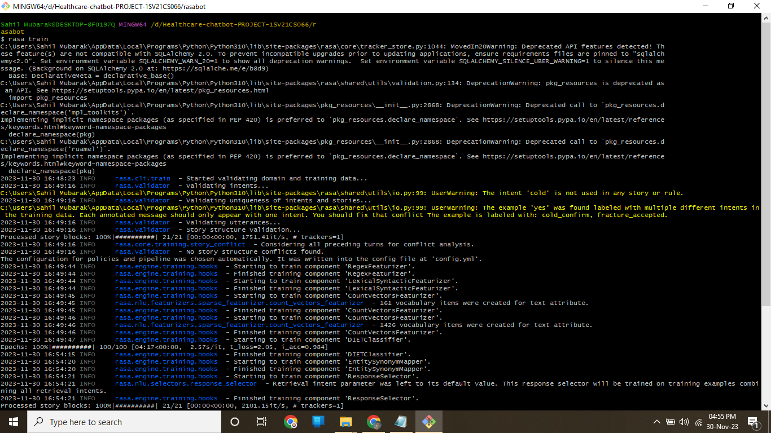

**Testing accuracy of the New Model:**

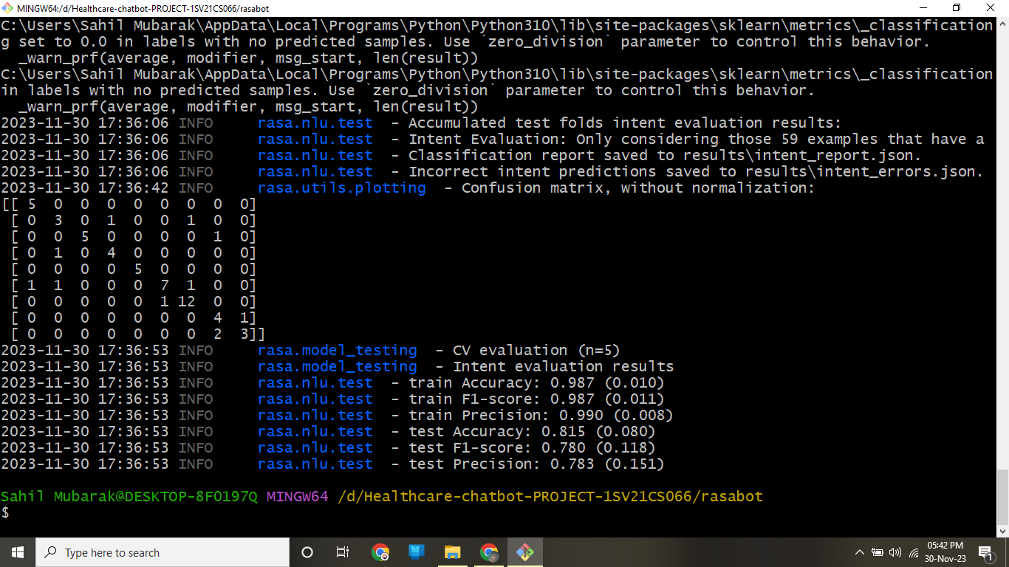

**Bot testing with new Data:**

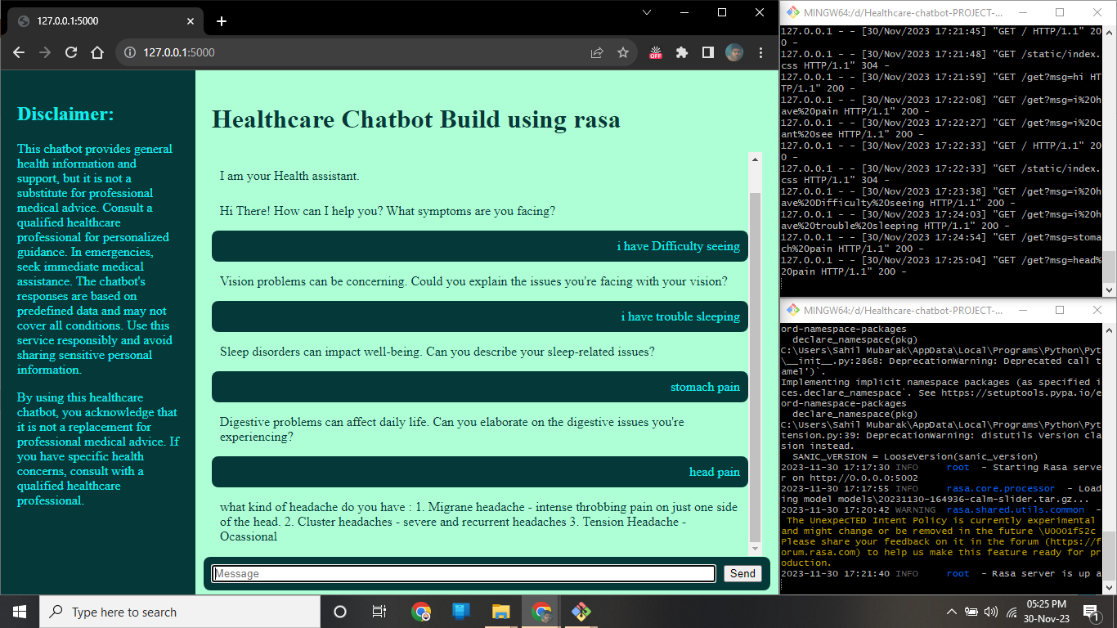

**New Front end Webpage:**

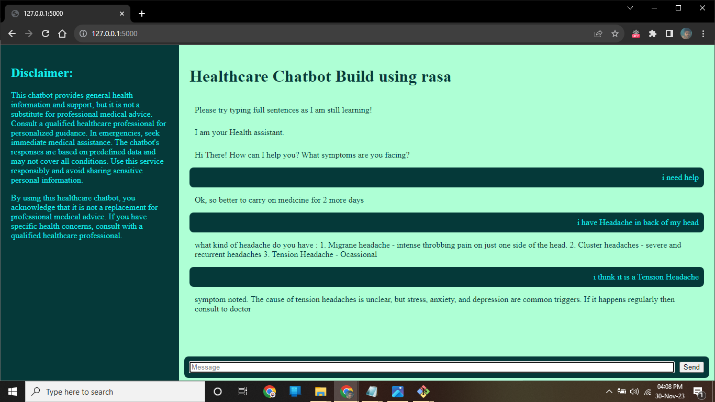

# [CHAPTE](https://1.bp.blogspot.com/-dODuK8N5h1Q/Wlnyb3V9HFI/AAAAAAAACL4/WxQtCJ1pM5wccDABg4wIrTBUB0vlikXQQCLcBGAs/s1600/poly1.jpg)R 9 CONCLUSION

* 1. **CONCLUSION**

The package was designed in such a way that future modifications can be done easily. The following conclusions can be deduced from the development of the project:

* Automation of the entire system improves the efficiency
* It provides a friendly graphical user interface which proves to be better when compared to the existing system.
* It gives appropriate access to the authorized users depending on their permissions.
* It effectively overcomes the delay in communications.
* Updating of information becomes so easier
* System security, data security and reliability are the striking features.
* The System has adequate scope for modification in future if it is necessary.

# [CHAPTE](https://1.bp.blogspot.com/-dODuK8N5h1Q/Wlnyb3V9HFI/AAAAAAAACL4/WxQtCJ1pM5wccDABg4wIrTBUB0vlikXQQCLcBGAs/s1600/poly1.jpg)R 10

# REFERENCES

# REFERENCE

1. Rasa Documentation:

https://rasa.com/docs/

2. Flask Documentation:

https://flask.palletsprojects.com/

3. Git Documentation:

https://git-scm.com/doc

4. Visual Studio Code (VSCode) Documentation:

https://code.visualstudio.com/docs

5. HTML Tutorial:

https://www.w3schools.com/html/

6. CSS Tutorial:

https://www.w3schools.com/css/

7. JavaScript Tutorial:

https://www.w3schools.com/js/

8. Python Documentation:

https://docs.python.org/